Date of first appointment:

/
month

day
/ Time of appointment:
year
Birthplace:

Name: last first middle initial maiden Birthdate:
/
month

day
/
year

Address:
street
Age
Sex: F M

city state zip
Telephone: Home: ( ) Work: ( )

Occupation: ____________________________________________ Full Time Part Time Retired

MARITAL STATUS: Never Married Married Divorced Separated Widowed

Spouse/Significant Other: Alive/Age
(Circle your criteria from each section below):
Deceased/Age Major Illnesses:

Race: American Indian or Alaska Native, Asian, Black or African American, Caucasian/White, Native Hawaiian or Other Pacific Islander, Multiracial, Refused/Decline or Unknown
Ethnicity: Hispanic or Latino, Not Hispanic or Latino, Refused/Declined or Unknown
Preferred Language: English, Spanish, Refused/Decline or Unknown
Referred here by: (check one) Self Family Friend Doctor Other Health Professional
Name of person making referral: The name of the physician providing your primary medical care: Describe briefly your present symptoms:

Date symptoms began (approximate): Diagnosis:
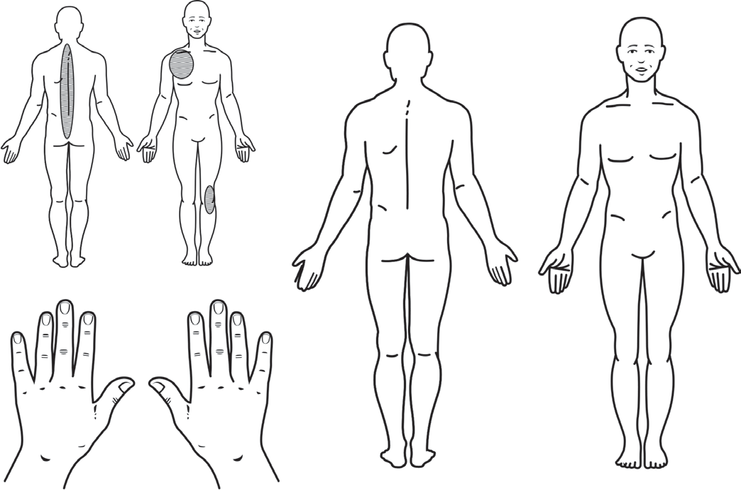Previous treatment for this problem (include physical therapy, surgery and injections; medications to be listed later):
Example:
Please shade all the locations of your pain over the past week on the body figures and hands.
LEFT
RIGHT
LEFT
LEFT
RIGHT
Adapted from CLINHAQ, Wolfe F and Pincus T. Current Comment – Listening to the patient – A practical guide to self report questionnaires in clinical care. Arthritis Rheum. 1999;42 (9): 1797-808. Used by permission.

Please list the names of other practitioners you have seen for this problem:

SYSTEMS REVIEW
As you review the following list, please check any problems, which have significantly affected you:
Date of last mammogram: / / Date of last eye exam: / / Date of last chest x-ray: / / Date of last Tuberculosis Test / / Date of last bone densitometry / /

Constitutional
Recent weight gain
amount
Recent weight loss
amount Fatigue
Weakness Fever Eyes
Pain
Redness
Loss of vision
Double or blurred vision Dryness
Feels like something in eye Itching eyes

Ears-Nose-Mouth-Throat
Ringing in ears Loss of hearing Nosebleeds
Loss of smell
Dryness in nose Runny nose
Sore tongue Bleeding gums
Sores in mouth Loss of taste
Dryness of mouth
Frequent sore throats Hoarseness
Difficulty swallowing

Cardiovascular
Chest Pain
Irregular heart beat
Sudden changes in heart beat High blood pressure
Heart murmurs

Respiratory
Shortness of breath
Difficulty breathing at night Swollen legs or feet
Cough
Coughing of blood Wheezing (asthma)

Gastrointestinal
Nausea
Vomiting of blood or coffee ground material
Stomach pain relieved by food or milk Jaundice
Increasing constipation Persistent diarrhea
Blood in stools Black stools
Heartburn

Genitourinary
Difficult urination
Pain or burning on urination Blood in urine
Cloudy, “smoky” urine Pus in urine
Discharge from penis/vagina
Getting up at night to pass urine Vaginal dryness
Rash/ulcers
Sexual difficulties Prostate trouble For Women Only:
Age when periods began:
Periods regular? Yes No
How many days apart? Date of last period? / / Date of last pap? / / Bleeding after menopause? Yes No Number of pregnancies? Number of miscarriages?

Musculoskeletal
Morning stiffness Lasting how long?
Minutes Hours Joint pain
Muscle weakness Muscle tenderness
Joint swelling
List joints affected in the last 6 mos.

Integumentary (skin and/or breast)
Easy bruising Redness
Rash Hives
Sun sensitive (sun allergy) Tightness
Nodules/bumps Hair loss
Color changes of hands or feet in the cold

Neurological System
Headaches Dizziness Fainting
Muscle spasm
Loss of consciousness
Sensitivity or pain of hands and/or feet Memory loss
Night sweats

Psychiatric
Excessive worries Anxiety
Easily losing temper Depression
Agitation
Difficulty falling asleep Difficulty staying asleep Endocrine
Excessive thirst

Hematologic/Lymphatic
Swollen glands Tender glands Anemia
Bleeding tendency
Transfusion/when

Allergic/Immunologic
Frequent sneezing
Increased susceptibility to infection

SOCIAL HISTORY
Do you drink caffeinated beverages?

PAST MEDICAL HISTORY
Do you now have or have you ever had: (check if “yes)

Cups/glasses per day? Do you smoke? Yes No Past – How long ago? Do you drink alcohol? Yes No Number per week Has anyone ever told you to cut down on your drinking?
Yes No
Do you use drugs for reasons that are not medical? Yes No
If yes, please list:
Cancer MS
CHF
Depression
Kidney disease Blood Clot (DVT/PE)
COPD/ Emphysema
Heart problems Leukemia
Diabetes
Stomach ulcers Diverticulitis
Pneumonia Fracture
Glaucoma
Asthma Stroke Crohn’s
Ulcerative Colitis
Psoriasis
High Blood Pressure Tuberculosis

Do you exercise regularly? Yes No
Type Amount per week How many hours of sleep do you get at night? Do you get enough sleep at night? Yes No
Do you wake up feeling rested? Yes No
Other significant illness (please list)

Natural or Alternative Therapies (chiropractic, magnets, massage, over- the-counter preparations, etc.)

PREVIOUS SURGERIES
Type | Year | Reason
1.
2.
3.
4.
5.
6.
7.
Any previous fractures? No Yes Describe:

Any other serious injuries? No Yes Describe:

FAMILY HISTORY

IF LIVING IF DECEASED

Age Health Age at Death Cause

Father
Mother

Number of siblings Number living Number of children Number living
Number deceased Number deceased

List ages of each
___

___

___

___

___

Health of children

Do you know any blood relative who has or had: (check and give relationship)

Thyroid Disease Multiple Sclerosis Crohn’s Ulcerative Colitis
Rheumatoid Arthritis Lupus (SLE) Psoriasis Psoriatic Arthritis
Heart Disease Stroke Asthma Psoriasis
Tuberculosis Type 1 Diabetes Ankylosing Spondylitis
Arthritis _______________

MEDICATIONS
Drug allergies: No Yes If yes, please list:

Type of reaction:

PRESENT MEDICATIONS (List any medications you are taking. Include such items as aspirin, vitamins, laxatives, calcium and other supplements, etc.)
Name of Drug | Dose (include strength & number of pills per day) | How long have you taken this medication | Please check: Helped?
 |  |  | A Lot | Some | Not At All
1.
2.
3.
4.
5.
6.
7.
8.
9.
10.
PAST MEDICATIONS: Please review this list of “arthritis” medications. As accurately as possible, try to remember which medications you have taken, how long you were taking the medication, the results of taking the medication and list any reactions you may have had. Record your comments in the spaces provided.
Drug names/Dose | Length of time | Please check: Helped?  A Lot Some Not At All |  |  | Reactions
Non-Steroidal Anti-Inflammatory Drugs (NSAIDs)
Circle any you have taken in the past
Flurbiprofen Diclofenac + misoprostil Aspirin (including coated aspirin) Celecoxib Sulindac Oxaprozin Salsalate Diflunisal Piroxicam Indomethacin Etodolac Meclofenamate
Ibuprofen Fenoprofen Naproxen Ketoprofen Tolmetin Choline magnesium trisalcylate Diclofenac
Pain Relievers
Acetaminophen
Codeine
Propoxyphene
Other:
Other:
Disease Modifying Antirheumatic Drugs (DMArDS)
Certolizumab
Golimumab
Hydroxychloroquine
Penicillamine
Methotrexate
Azathioprine
Sulfasalazine
Quinacrine
Cyclophosphamide
Cyclosporine A
Etanercept
Infliximab
Tocilizumab
Other:
Other:

PAST MEDICATIONS Continued

Drug names/Dose | Length of time | Please check: Helped? |  |  | Reactions
 |  | A Lot | Some | Not At All
Osteoporosis Medications
Estrogen
Alendronate
Etidronate
Raloxifene
Fluoride
Calcitonin injection or nasal
Risedronate
Other:
Other:
Gout Medications
Probenecid
Colchicine
Allopurinol
Other:
Other:
Others
Tamoxifen
Tiludronate
Cortisone/Prednisone
Hyaluronan
Herbal or Nutritional Supplements
Please list supplements:

Have you participated in any clinical trials for new medications? Yes No
If yes, list:

ACTIVITIES OF DAILY LIVING
Do you have stairs to climb? Yes No If yes, how many?
How many people in household? Relationship and age of each Who does most of the housework? Who does most of the shopping? Who does most of the yard work? On the scale below, circle a number which best describes your situation; Most of the time, I function…
1 | 2 | 3 | 4 | 5
VERY | POORLY | OK | WELL | VERY
POORLY |  |  |  | WELL

Because of health problems, do you have difficulty:
(Please check the appropriate response for each question.) Usually Sometimes No
Using your hands to grasp small objects? ........................................................................................................................ ☐ ☐ ☐
Walking? ............................................................................................................................................................................☐ ☐ ☐
Climbing stairs? .....................................................................................................................................................................................☐ ☐ ☐
Descending stairs?..............................................................................................................................................................☐ ☐ ☐
Sitting down?.....................................................................................................................................................................☐ ☐ ☐
Getting up from chair?.................................................................................................................................................................☐ ☐ ☐
Touching your feet while seated? ..........................................................................................................................................................☐ ☐ ☐
Reaching behind your back? ..................................................................................................................................................................☐ ☐ ☐
Dressing yourself? ..................................................................................................................................................................................☐ ☐ ☐
Going to sleep? ......................................................................................................................................................................................☐ ☐ ☐
Staying asleep due to pain? ..................................................................................................................................................................☐ ☐ ☐
Obtaining restful sleep?...............................................................................................................................................................☐ ☐ ☐
Bathing?..........................................................................................................................................................................☐ ☐ ☐
Eating?............................................................................................................................................................................☐ ☐ ☐
Working? ............................................................................................................................................................................☐ ☐ ☐
Getting along with family members?...........................................................................................................................................☐ ☐ ☐
In your sexual relationship? ...................................................................................................................................................................☐ ☐ ☐
Engaging in leisure time activities?........................................................................................................................................................☐ ☐ ☐
With morning stiffness.................................................................................................................................................................☐ ☐ ☐
Do you use a cane, crutches, walker or wheelchair? (circle one) .........................................................................................................☐ ☐ ☐
What is the hardest thing for you to do? __________________________________________________________________________

Are you receiving disability? ........................................................................................................................................................Yes No
Are you applying for disability?....................................................................................................................................................Yes No
Do you have a medically related lawsuit pending? ......................................................................................................................Yes No

